MATHEMATICS PROJECT
CLASS: 9
TOPIC: MID POINT THEOREM
STATEMENT: The straight line joining the mid points of any two sides of a triangle is parallel to the third side and is equal to half of it.
OBJECTIVE: To verify the above theorem by activity.
PRE-REQUISITE KNOWLEDGE: If a transversal cuts two straight lines and if a pair of corresponding angles are equal, then the straight lines are parallel.
MATERIALS REQUIRED:
- Geometry box
- Practical workbook
- Sheets of white paper.
- Coloured ball point pens.
- Scissors
- Scale
- Sketch pen
- Adhesives or glue sticks
- Tracing papers – 2
PROCEDURE:
- Draw any triangle ABC, where AB = 5 cm, BC = 7 cm and CA = 6 cm, on a white sheet paper and mark the mid-points D, E and F of the sides AB, AC and BC.
- Fold the triangle along the mid-points of the two adjacent sides to form a crease in each of the cases.
- Mark the angles 1, 2, 3, 4 and 5 as shown in the figure.
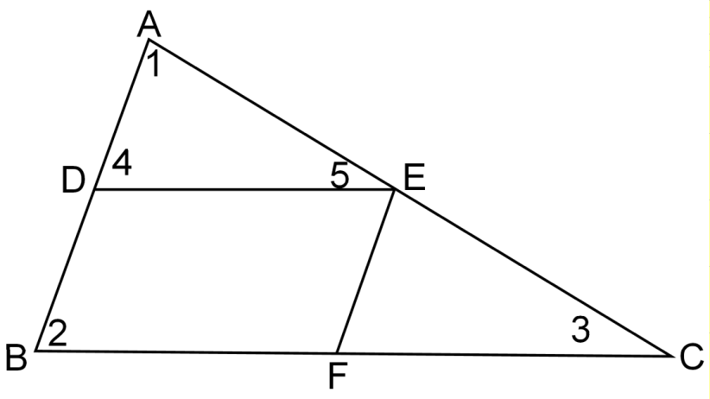
- Draw horizontal lines in the triangle ABC by pink ball point pen.
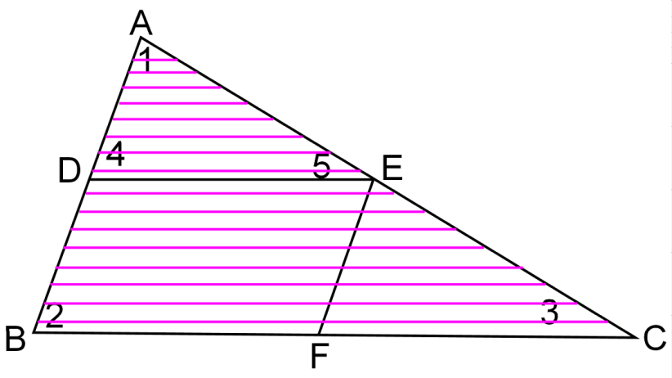
- Make a replica of triangle ADE on a tracing paper and draw vertical lines with blue ball point pens as shown in the diagram.
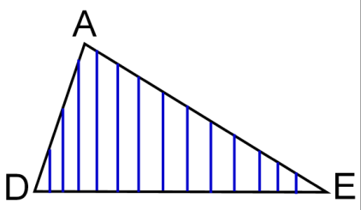
- Paste/superimpose the triangle ADE on the triangle EFC as shown in the figure.
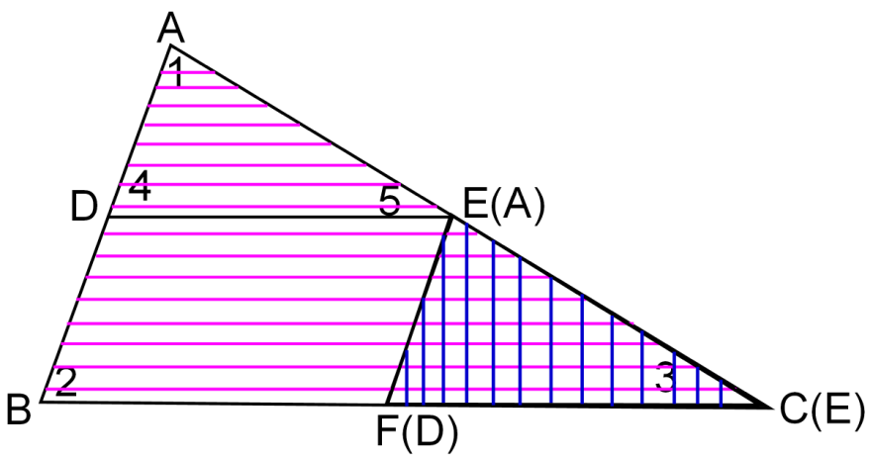
RESULT:
We observe that the triangle ADE exactly covers the triangle EFC and note that the vertex A of $∆ADE$ falls on the vertex E of $∆EFC,$ the vertex D falls on the vertex F and the vertex E falls on C.
It also follows that $∠5= ∠3 ⇒DC ∥BC$ and DE = $\frac{1}{2}$BC. Hence the straight line joining the mid-points of any two sides of a triangle is parallel to the third side and is equal to half of it.

LAST DATE OF SUBMISSION OF PROJECT: 28th November, 2014

