ENVIRONMENTAL EDUCATION PROJECTS OF Final Term Evaluation 2015-2016
TOPICS :
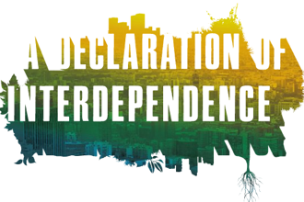
CLASS 5: Interdependence between Living Beings. Project will be done in file.
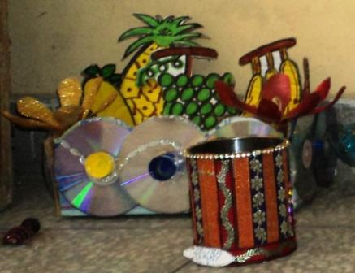
CLASS 6: Best of Waste. Project will be done in a file.
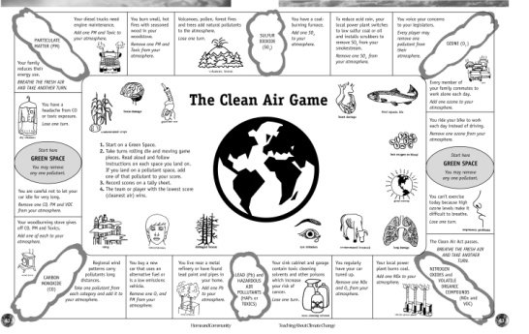
CLASS 7: Response of Living beings to change in Environment. Project will be done in file.
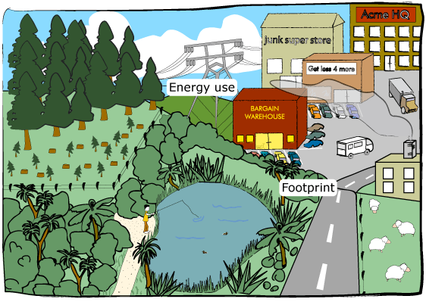
CLASS 8: Factors affecting Environment. Project will be done in file.

