MATHEMATICS PROJECT
CLASS: 8
TOPIC: AREA OF A PARALLELOGRAM
OBJECTIVE: To find a formula for the area of a parallelogram
PRE-REQUISITE KNOWLEDGE: Formula for the area of a parallelogram
MATERIALS REQUIRED:
- Geometry box
- Practical workbook
- Coloured chart papers – yellow, blue and red
- Scissors
- Scale
- Sketch pen
- Adhesives or glue sticks
- Tracing papers – 2
PROCEDURE:
- Draw any parallelogram of base b and height h on a yellow coloured chart paper.
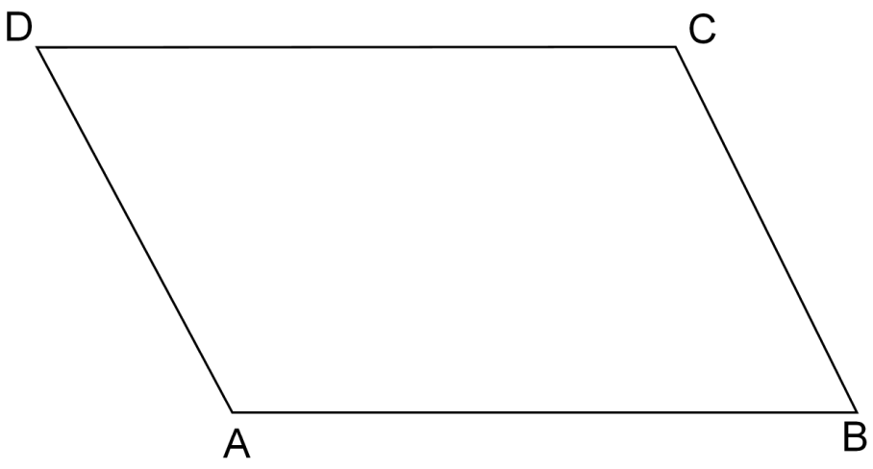
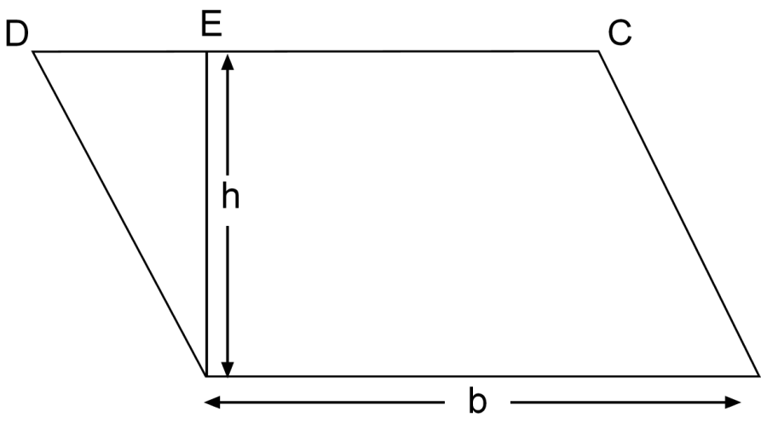
- From A draw AE perpendicular to DC. Place a tracing paper on the parallelogram ABCD. Trace out $∆A DE.$
- Place the tracing paper on a blue chart paper. Trace and cut the triangle $∆A DE$ from it.
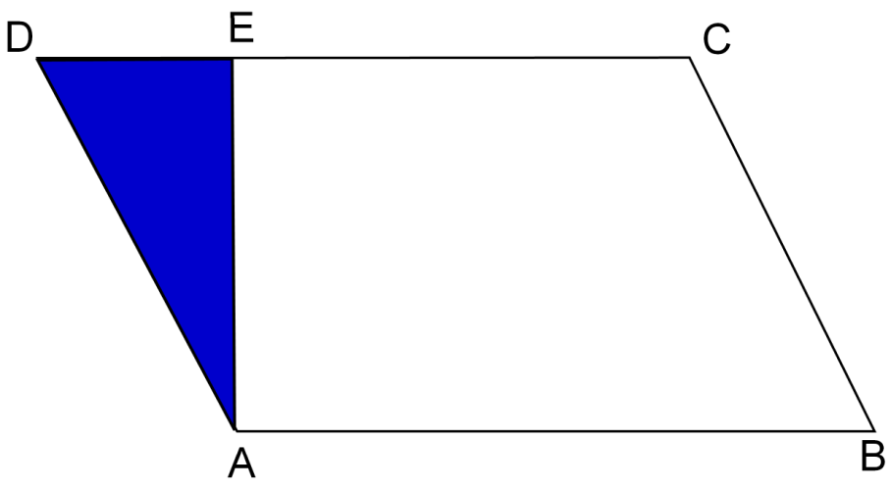
- Similarly with the help of the tracing paper, trace out the remaining portion of the parallelogram ABCD on it (quadrilateral ABCE).
- Now place the tracing paper on a red chart paper. Trace and cut the quadrilateral ABCE from it.
- Now paste the quadrilateral ABCE and $∆A DE$ on the yellow chart paper as shown in the figure.
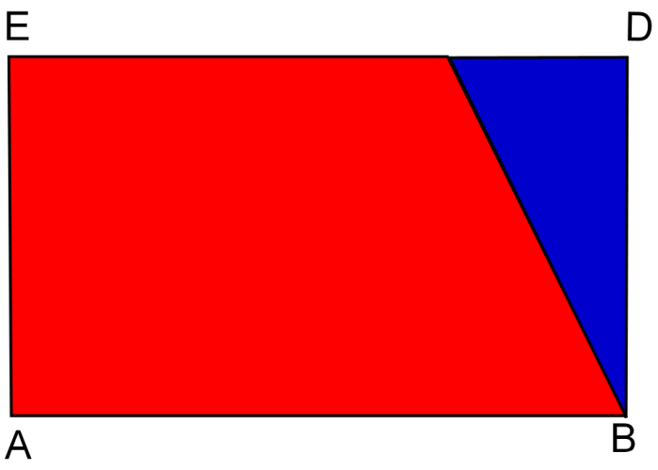
- We get the rectangle ABDE.
- Hence area enclosed by the parallelogram ABCD and the rectangle ABDE are equal.
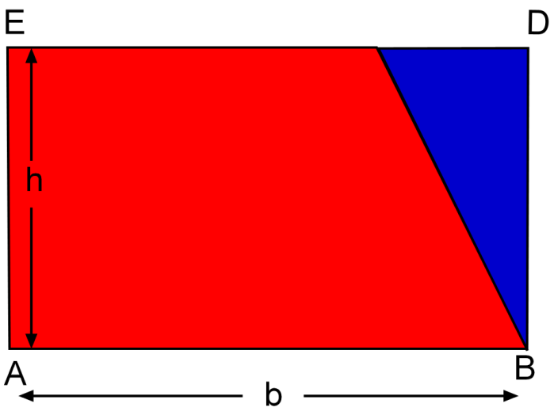
RESULT:
Area of the parallelogram ABCD = area of the rectangle ABDE = $b ×h=base ×height$
LAST DATE OF SUBMISSION OF PROJECT: 15th July, 2017

