ENVIRONMENTAL EDUCATION PROJECTS OF 1st Term Session 2015-2016
TOPICS :
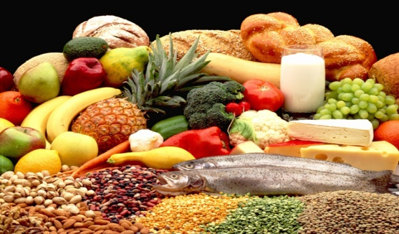
CLASS 5: Our food and US- proteins, carbohydrates, fats, vitamins and minerals. Project will be done in file.
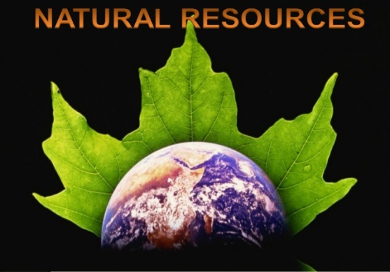
CLASS 6: Natural Resources. Project will be done in a file.
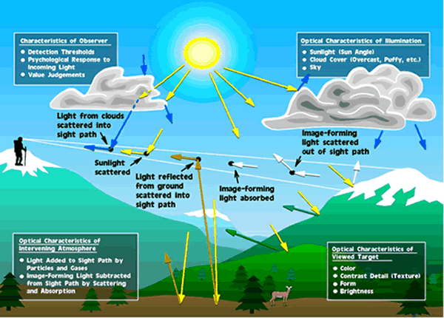
CLASS 7: Air. Project will be done in file.
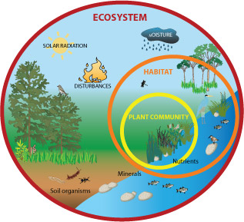
CLASS 8: Energy Flow through Eco System. Project will be done in file.

