MATHEMATICS PROJECT
CLASS: 9
TOPIC: FACTORISATION OF QUADRATIC POLYNOMIALS
OBJECTIVE: Learning geometrical representation of the factorization of the following quadratic polynomials.
- $x^{2}+5x+6$
- $x^{2}-x-6$
- $x^{2}-5x+6$
- $2x^{2}-5x+2$

PRE-ACQUIRED KNOWLEDGE:
- Splitting the middle term of a quadratic polynomial
- Formula for the area of a square and of a rectangle
MATERIAL REQUIRED:
- Pink and blue coloured chart papers
- White sheets of paper
- Geometry box
- Pair of scissors
- Fevistick/gum
- Mathematics Project File and File papers
PLANNING:
- Every $x^{2}$ will be represented by the area of a pink square of side $x$ units as shown in the figure
- Thus to represent $2x^{2}$we use two pink squares of side $x$ units each.
- Every $x$ will be represented by a pink rectangular strip of dimensions $1×x$ as shown in the adjoining figure. Thus to represent $5x$ we use 5 rectangular strips of dimensions $1×x$ each.
- Every $-x$ will be represented by a blue rectangular strip of dimensions $1×x$ as shown in the adjoining figure. Thus to represent $-3x$ we use 3 rectangular strips of dimensions $1×x$ each.
- All positive integers will be represented by blue unit squares as shown in the adjoining figure. Thus to represent 6, we use 6 pink unit squares.
- All negative integers will be represented by pink unit squares as shown in the adjoining figure. Thus to represent $-6$, we use 6 blue unit squares.
- Blue strips and blue unit squares means to cut off the area equal to the area of these pieces.

PROCEDURE:
- Factorisation of $x^{2}+5x+6$.
- The polynomial $x^{2}+5x+6$ can be written as $x^{2}+3x+2x+6$
- To represent $x^{2}$, take a pink square of side $x$ units, to represent 3$x$ take 3 pink rectangular strips of dimensions of $1×x$ units each; to represent $2x$ take 2 pink rectangular strips of dimensions $1×x$ units each and to represent 6 take 6 pink unit squares.
- Thus to represent $x^{2}+3x+2x+6$ paste all the above pieces on a white sheet of paper as shown.

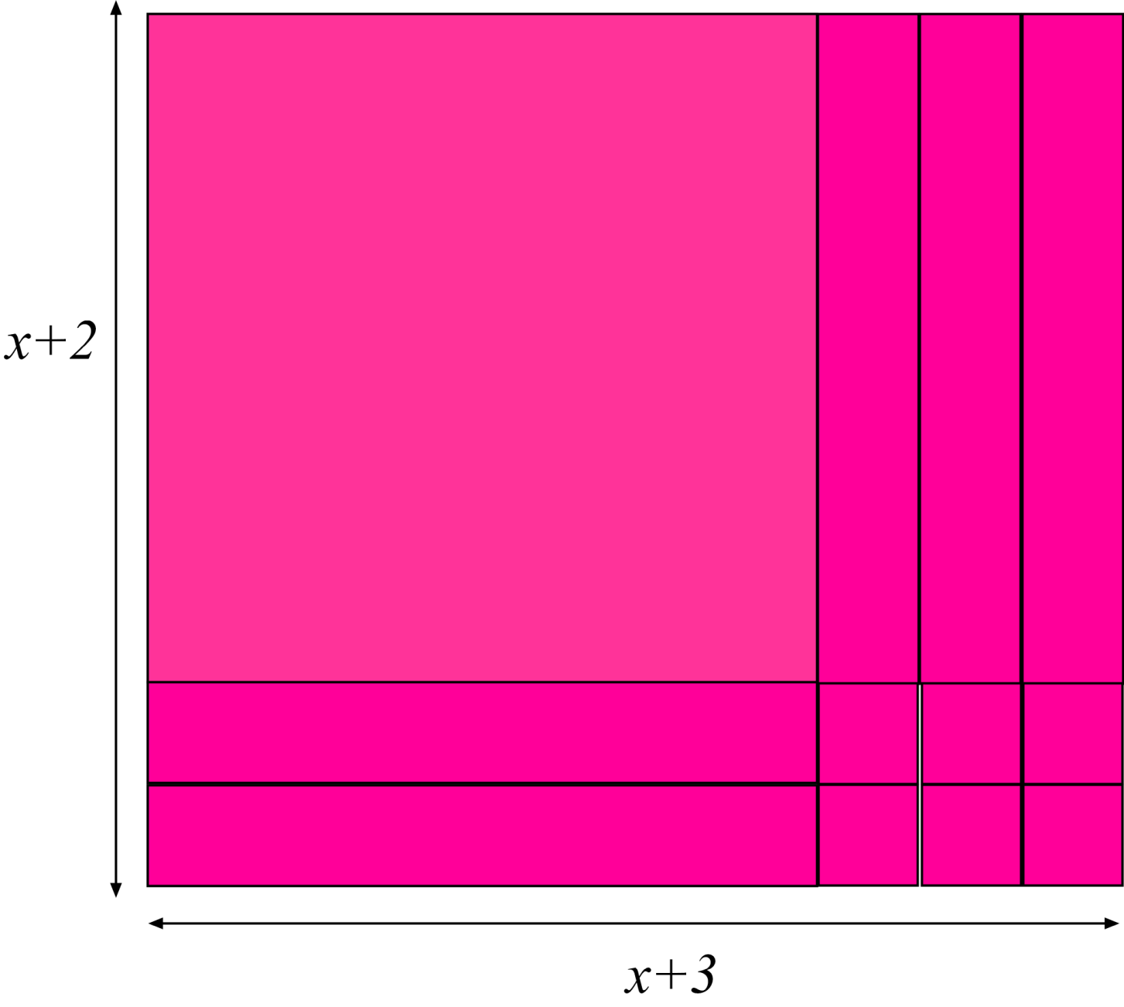
RESULT:
We observe that the area of the rectangle is $(x+3)(x+2)$ and hence $x^{2}+5x+6=(x+3)(x+2)$
CAN YOU DO THE REST YOURSELF?

