Proposed Projects for HISTORY and CIVICS for Annual Evaluation 2014
Last Date of Submission : 15th of January 2015

Class 5 : Topic- Communications, it’s different modes on Chart Paper or as models.
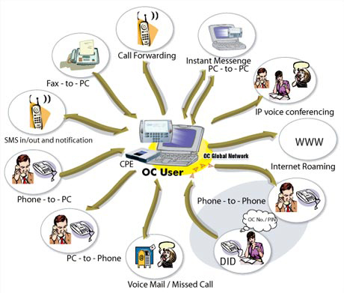
Class 6 : Topic- Vedic Age, Chaturasharama and Gurukula on Chart Paper.
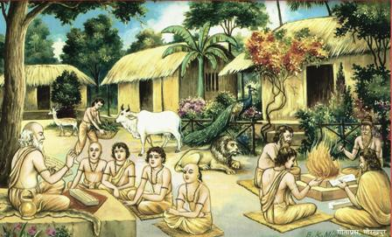
Class 7 : Topic- Mughal Art and Architecture as models and Aural.
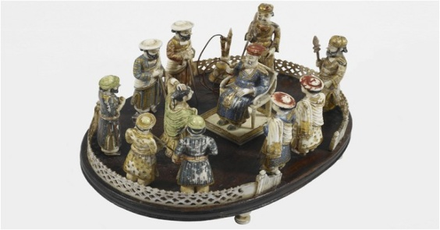
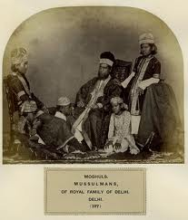
Class 8: Topic- Write a new Constitution and compare and contrast with the existing Constitution of India , on Project File in classroom.
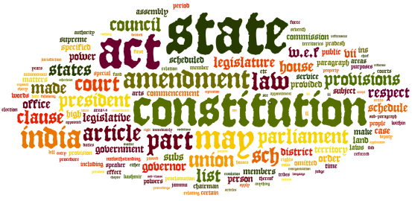

Class 9: Topic-Mughal: Chronology, Wars, Architecture and Administration
on Files as well as orals.

