Proposed Projects for History and Civics [HCGI] Annual Evaluation 2016-2017
Last Date of Submission : 14thof December Class 10 and rest 15th of January 2016

Class 5 : Topic- Fundamental Dutiess, Collage on half
Chart Paper from Newspaper and Magazines.
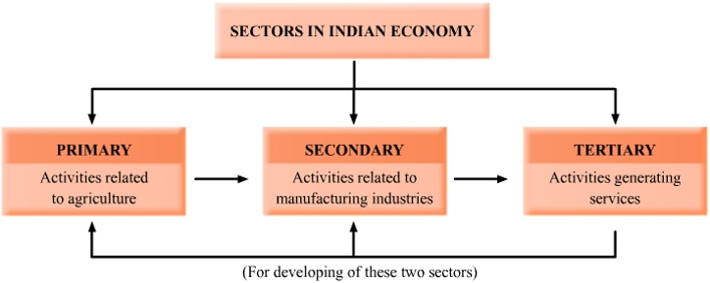
Class 6 : Topic- Compare and Contrast between Urban and Rural Life
, Emphasise on 3 Sectors of Economy
on Chart Paper.

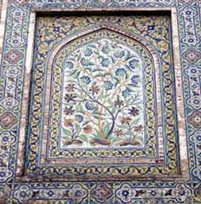
Class 7 : Topic- Mughal Art and Architecture.
Pictographic expression on the specifics and significance of
Art and Architecture.

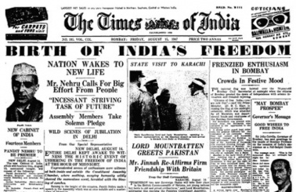
Class 8: Topic- India towards Freedom 1919-1947. Edit a newspaper of
A particular date and event. Class Project.

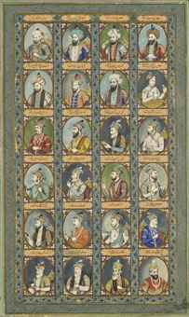
Class 9: Topic-Create a picture gallery recording the Mughal Chronology
And their contributions. On Chart Paper, class Project.

Class 10: Topic- Present the historical Significance and Impact of World War I and II.
File and Class Project.
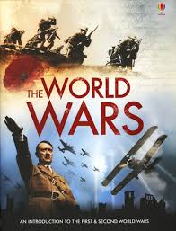
Proposed Projects for Geography [HCGII] Annual Evaluation 2016-2017
Last Date of Submission : 14thof December Class 10 and rest 15th of January 2016
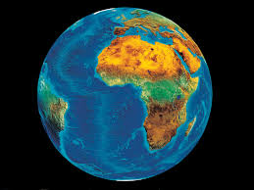

Class 5 : Topic- Our Planet: The Earth. On file, [Maximum
5-7 pages].

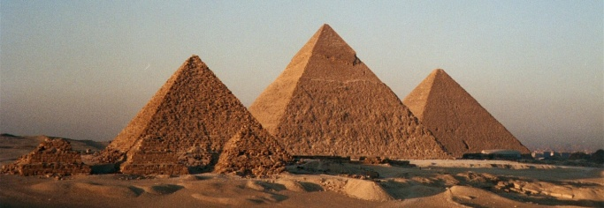
Class 6 : Topic- A case study on Pyramids of Egypt.
An analytical study of the development of the Project
on Chart Paper.

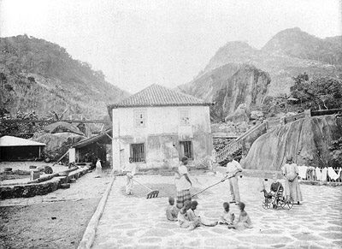
Class 7 : Topic- Coffee Fazendas in Brazil with special
Emphasis on the recent trends in growing
Coffee . File Project.

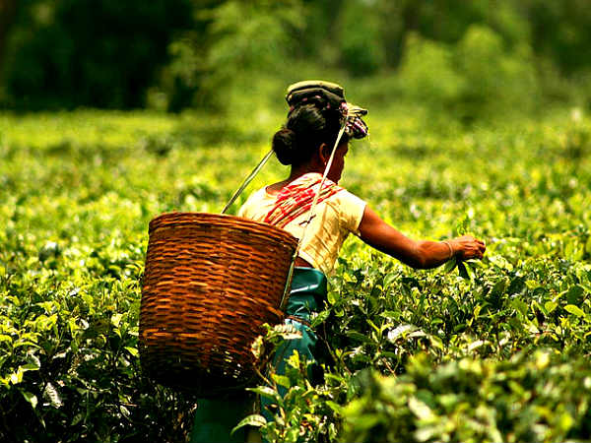
Class 8 : Topic- Plantations in India with special
Emphasis on Tea, Rubber and Coffee.
File Project.

Class 9 : Topic- 1. Topographical interpretation.
2. Compare and Contrast the Temperate and Tropical
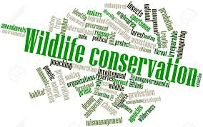
Grassland with special emphasis on Location, Climate, Natural Vegetation
and Human Adaptation.

Class 10 : Topic- Wildlife Conservation with special
Efforts in India. File Project.

Proposed Projects for Environmental Education Annual Evaluation 2016-2017
Last Date of Submission : 15th of January 2016

Class 5 : Topic- Pollution. On Chart Paper ,Class Project.

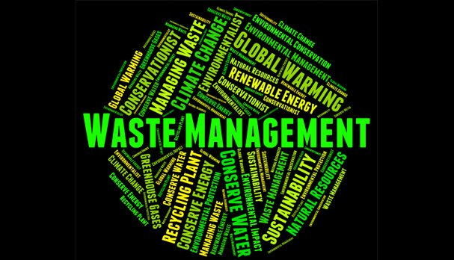
Class 6 : Topic- Management of Waste..
On Chart Paper, Class Project.

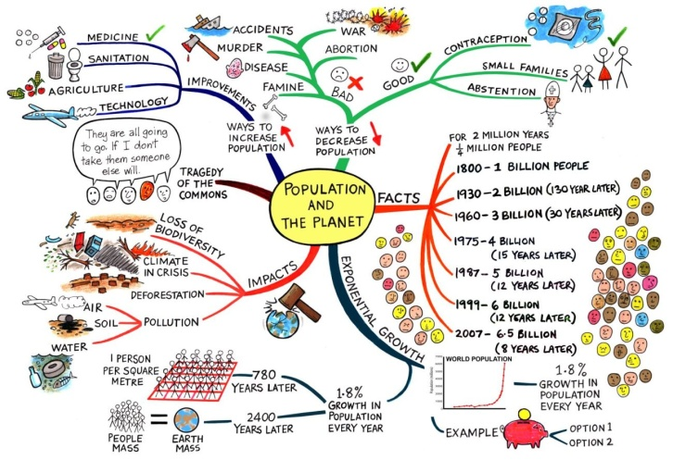
Class 7 : Topic- Effect of Human Activities and Population Growth.
File Project.

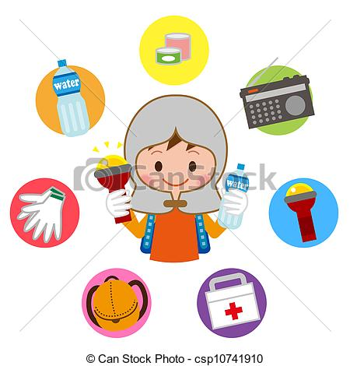
Class 8 : Topic-Disaster and it’s Management.
File Project.

