Topics and Schedule of EEd Projects 1st Term, Session 2014-2015
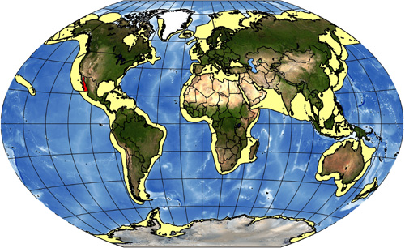

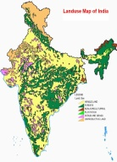
Class 5 : Land and People

Class 6 : Interdependence in Environment

Class 7 : Air

Class 8 : Eco System

