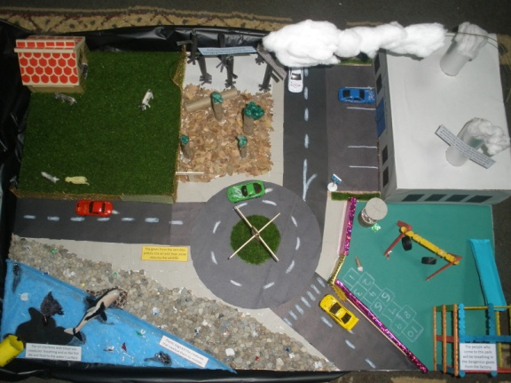
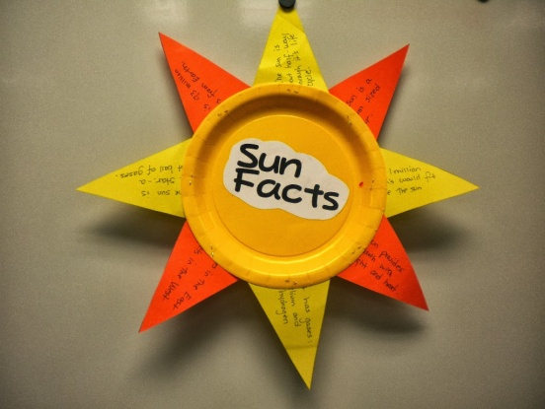
Topics and Schedule of Geography Projects 1st Term, Session 2014-2015

Class 5 : Rotation and Revolution / 28th April -10th May 2014

Class 6 : Solar System / 28th April - 7th May 2014

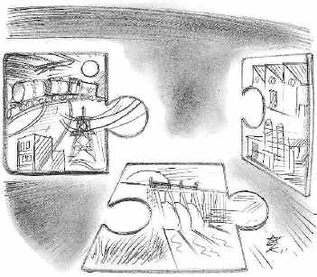
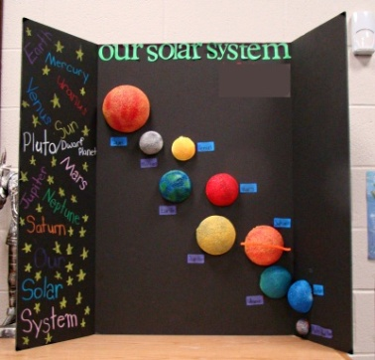
Class 7 : The Four Realms of Earth / 10th April - 22nd April 2014

Class 8 : Climate of Asia / 10th May - 24th April 2014

Class 9 : Pollution / 3rd April- 17th April 2014

Class 10 : Need for Industrialisation in India, the latest trend and its impact on economy of India / 2nd April-23rd April 2014 .
