HISTORY PROJECTS OF 1st Term Session 2015-2016
TOPICS :
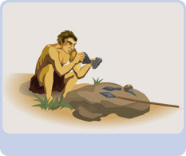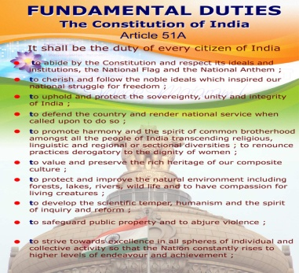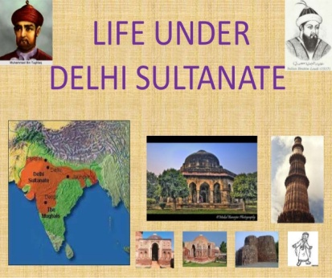
CLASS 5 : Inventions those made remarkable effects in the lifestyle. Paper/Fire/Telephone and Exchange of Goods. Projects will be based on Models.

CLASS 6: How family constitute a society and how rights and Duties paved the way for civic society? Class based projects in Chart paper.

CLASS 7: Development of administration and extension of kingdom under major rulers of Sultanate period Class based project on classwork exercise book.

CLASS 8: Mention the evils of early 18th century Indian society. Explain the achievements of Raja Rammohan roy,H Derozio,Swami Vivekananda,Vidyasagar and Dayananda Saraswati as Social Reformers. Class based projects on Aural.

CLASS 9: How does contemporary cinema or television serial help us in understanding the pre-modern past? Present your analysis on any film/television serial pertaining to a historical personage or period.

CLASS 10: Create a picture gallery recording the reactions to Indian Independence in 1947.
