TOPIC: (i) SUM OF EITHER PAIR OF OPPOSITE ANGLES OF A CYCLIC QUADRILATERAL IS 180^{O} (ii) IN A CYCLIC QUADRILATERAL THE EXTERIOR ANGLE IS EQUAL TO THE INTERIOR OPPOSITE ANGLE
OBJECTIVE: To verify that the (i) sum of either pair of opposite angles of a cyclic quadrilateral is 180º (ii) in a cyclic quadrilateral the exterior angle is equal to the interior opposite angle materials required
MATERIALS REQUIRED:
- Geometry box
- Practical workbook
- Coloured chart papers – yellow, blue and pink
- Scissors
- Scale
- Sketch pen
- Adhesives or glue sticks
- Tracing papers – 2
PROCEDURE:
- Draw a circle of 5 cm radius on a blue coloured chart paper. Use black sketch pen for drawing.
- Cut out the circle.
- Take a yellow chart paper. Cut it in the size of an A4 sheet and paste the circle on it.
- By paper folding get the chords AB, BC, CD and DA.
- Draw the line segments AB, BC, CD and DA. Cyclic quadrilateral ABCD is obtained.
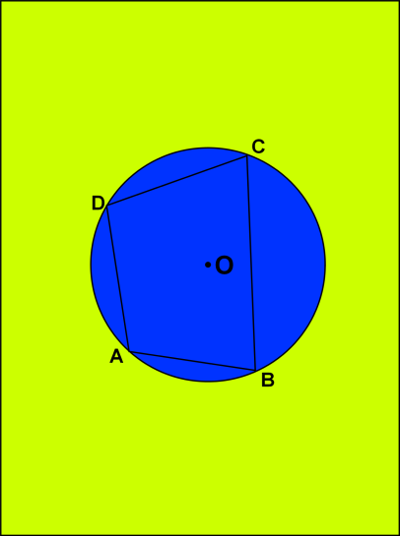
- Make a replica of cyclic quadrilateral ABCD using a tracing paper. Now draw the quadrilateral on the pink chart paper with the help of tracing paper and cut it out.
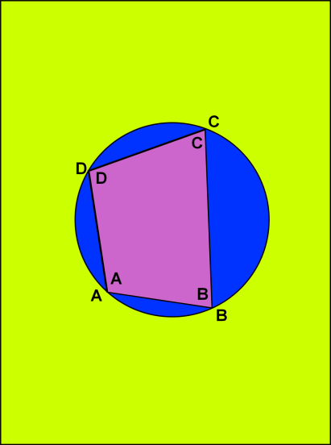
- Now cut the quadrilateral in 4 parts such that each part contain one angle like $∠A, ∠B, ∠C, ∠D$.
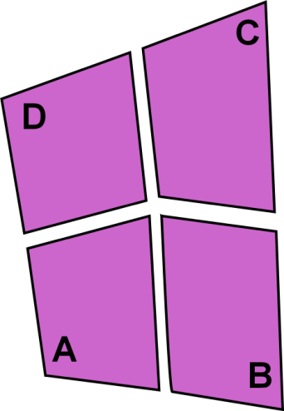
- Place $∠A$ and $∠C$ adjacent to each other.
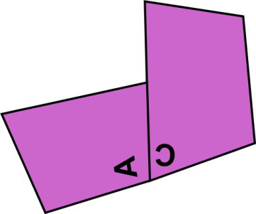
- Produce AB to form a ray AE. Exterior $∠CBE$ is formed.
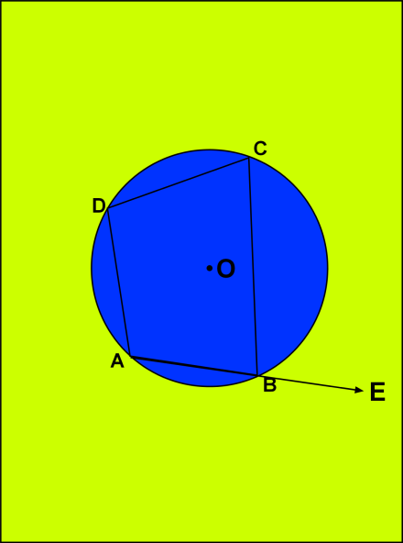
- Place the replica of D on $∠CBE$.
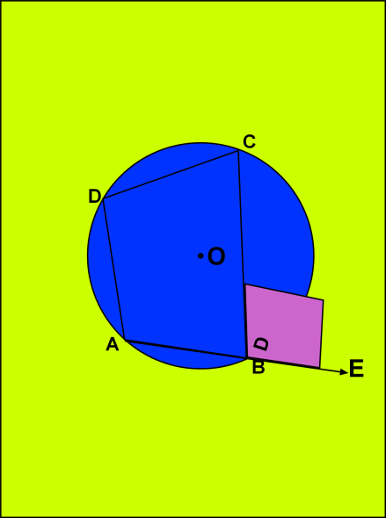
RESULT:
It is noted that when $∠A$and $∠C$ are placed adjacent to each other they form a linear pair:$∠A$ + $∠C$ = 180º. Also, $∠D$ completely covers $∠CBE$. This shows that the exterior angle of a cyclic quadrilateral ABCD is equal to the opposite interior angle.
LAST DATE OF SUBMISSION OF PROJECT: 15th July, 2017

