MATHEMATICS PROJECT
CLASS: 9 KB
TOPIC: ANGLE AT THE CENTRE OF A CIRCLE IS TWICE THE ANGLE SUBTENDED ON THE REMAINING PART OF THE CIRCLE
OBJECTIVE: To verify that the angle subtended by an arc at the centre of a circle is twice the angle subtended by the same arc at any other point on the remaining part of the circle, using methods of paper cutting, pasting and folding.
MATERIALS REQUIRED:
- Geometry box
- Practical workbook
- Coloured chart papers – yellow, blue and red
- Scissors
- Scale
- Sketch pen
- Adhesives or glue sticks
- Tracing papers – 2
PROCEDURE:
- Draw a circle of 5 cm radius on a blue coloured chart paper. Use black sketch pen for drawing.
- Cut out the circle.
- Take a yellow chart paper. Cut it in the size of an A4 sheet and paste the circle on it.
- Take two points A and B on the circle to obtain the arc AB.
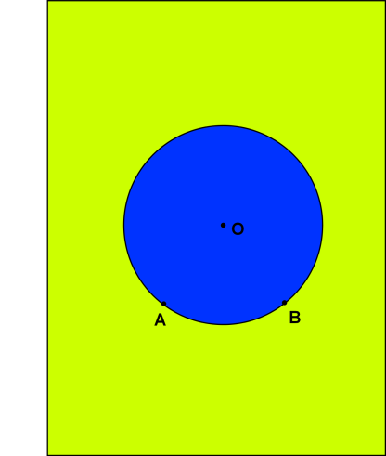
- Form a crease joining OA (by folding) and draw OA.
- Form a crease joining OB (by folding) and draw OB.
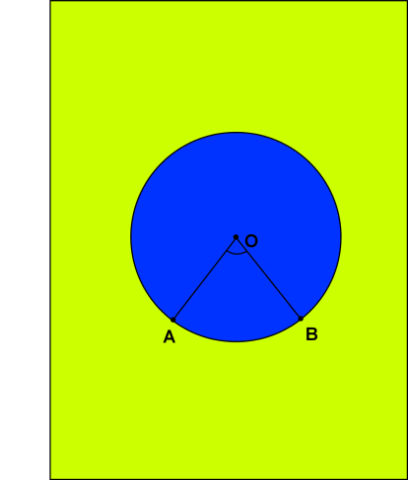
- Arc AB subtends $∠AOB$ at the centre O of the circle.
- Take a point P on the remaining part of the circle
- Form a crease joining AP (by folding) and draw AP.
- Form a crease joining BP (by folding) and draw BP.
- Arc AB subtends $∠APB$ at the point P on the remaining part of the circle.
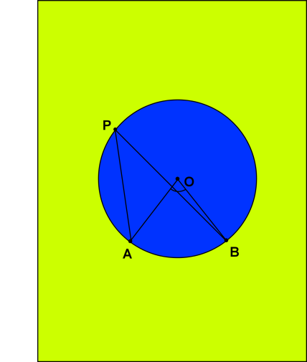
- Place tracing paper on the circle and draw a replica of the $∠APB$. Prepare two such replicas of $∠APB$ with green or red chart papers.
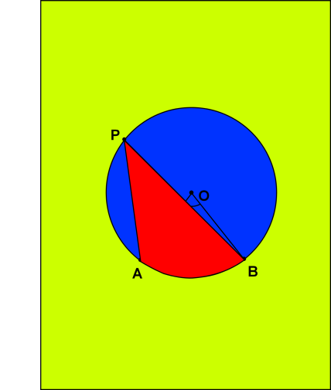
- Place the replicas adjacent to each other on $∠AOB$
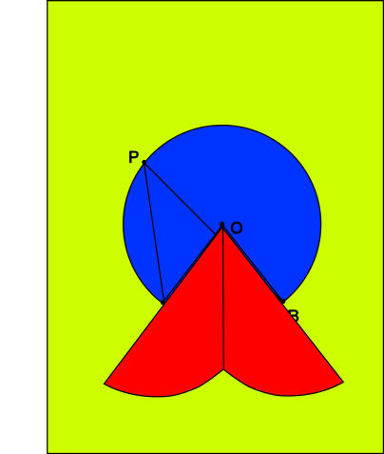
RESULT:
It is noted that the two replicas placed adjacently completely cover $∠AOB. ∴ ∠AOB=2∠APB$
LAST DATE OF SUBMISSION OF PROJECT: 15th July, 2017

