TOPIC: ARITHMETIC PROGRESSION
OBJECTIVE:
- To understand the concept of arithmetic sequences
- To use and manipulate the appropriate formulae
- To apply the knowledge of arithmetic sequences in a variety of contexts
PRIOR KNOWLEDGE:
- Patterns
- Basic number system
- Sequences
- Ability to complete tables
- Basic graphs in the co-ordinate planes
- Simultaneous equations with 2 unknowns
MATERIALS REQUIRED:
- Geometry box
- Practical workbook
- Coloured chart papers – yellow, blue and red
- Scissors
- Scale
- Sketch pen
- Adhesives or glue sticks
- Tracing papers – 2
PROCEDURE:
- Construct the pattern as shown with the dimension of small rectangles as 0.5 cm by 1 cm with different coloured craft or chart papers as per the specification.
- In the first row: $a_{1}= a_{1}+d.0$
- In the second row: $a_{2}= a_{1}+d.1$
- In the third row: $a_{3}= a_{1}+d.2$ and so on…..
- Now length of one row = $2a_{1}+(n-1)d$
- Area of the rectangle = $n\left\{2a_{1}+(n-1)d\right\}$
- Clearly area of the rectangle is twice the sum of progression.
- Hence sum of the progression == $\frac{n\left\{2a_{1}+\left(n-1\right)d\right\}}{2}$
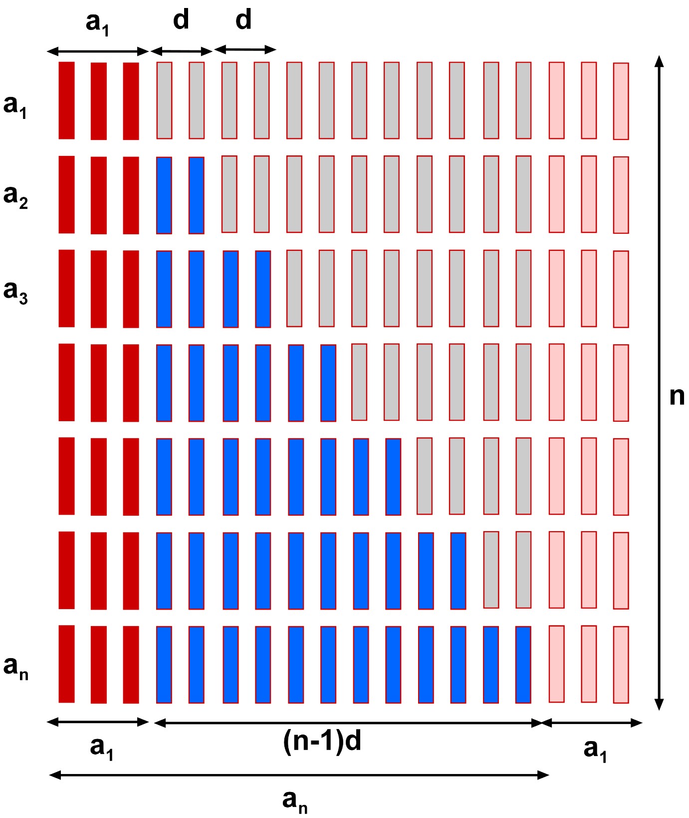

- Now consider this problem:
After the Knee-Surgery, The Doctor tells Mr. Sudhir to return to jogging program slowly. The Doctor suggests jogging for 12 minutes each day for the first week. Each week thereafter, he suggests Mr.Sudhir to increase that time by 6 minutes. How many weeks will it be before Mr. Sudhir are up to jogging 60 minutes per day?
REPRESENT THE ABOVE PROBLEM AS SHOWN ABOVE TO GET YOUR ANSWER
LAST DATE OF SUBMISSION OF PROJECT: 3rd December 2018

