Proposed Projects for HISTORY and CIVICS for Annual Evaluation 2015-2016
Last Date of Submission : 15th of January 2016
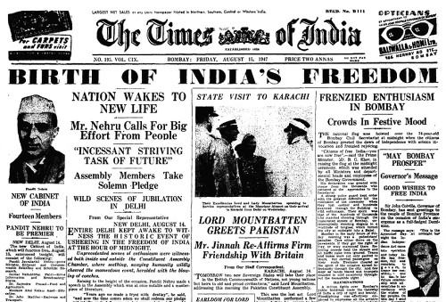
Class 5 : Topic- 15th August 1947 on Chart Paper .

Class 6 : Topic- Tenets and Teachings of Jainism and Buddhism.
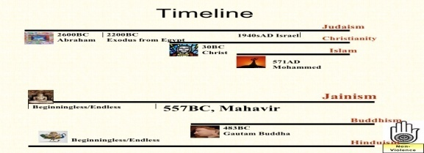
Based on Chart Paper.

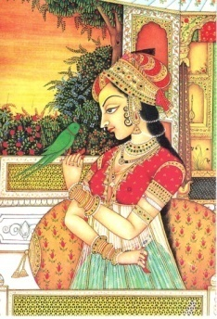
Class 7 : Topic- Mughal Paintings on Canvas, Group Project.

Class 8: Topic- Prepare a comparative study on Gandhian Movement of
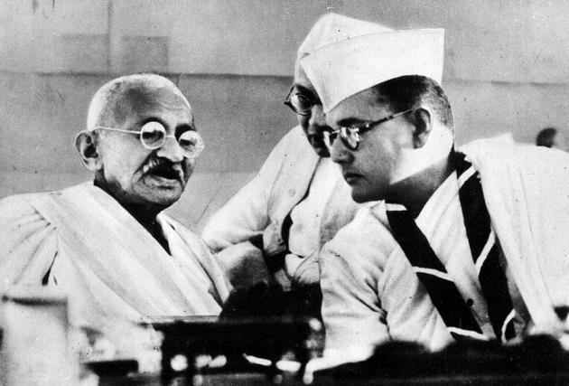
INC and INA. Ono

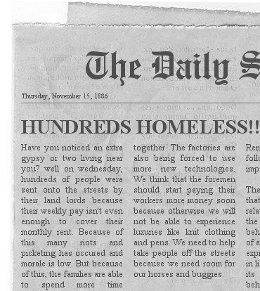
Class 9: Topic-Prepare a newspaper based on Industrial revolution.

Class 10: Topic- An illustrative and analytical study, on UNO and it’s
Organs and Agencies.[Submitted by 15th of December 2015]

