- TOPIC: VERIFICATION OF ALTERNATE SEGMENT THEOREM
OBJECTIVE: To verify that: If a line touches a circle and from the point of contact a chord is drawn, the angles between the tangent and the chord respectively are equal to the angles in the corresponding alternate segments.
MATERIALS REQUIRED:
- Geometry box
- Practical workbook
- Coloured chart papers – yellow, blue and red
- Scissors
- Scale
- Sketch pen
- Adhesives or glue sticks
- Tracing papers – 2
PROCEDURE:
- Draw a circle of 5 cm radius on a blue coloured chart paper. Use black sketch pen for drawing.
- Cut out the circle.
- Take a yellow chart paper. Cut it in the size of an A4 sheet and paste the circle on it.
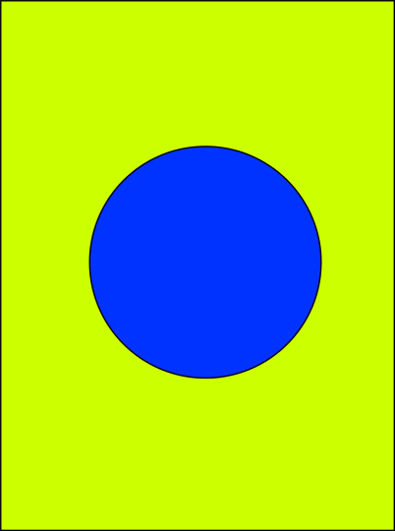
- Fold the sheet in such a way that it just touches the circle at A. Unfold the paper and draw the tangent PQ.
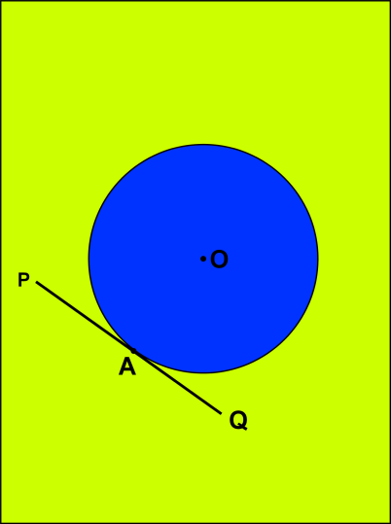
- Fold the paper starting from A such that the chord AB is obtained. Draw AB.
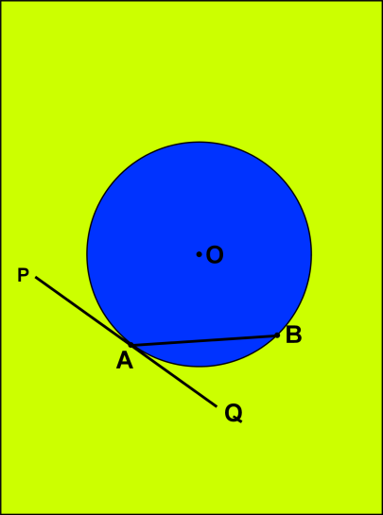
- $∠BAP$ and $∠BAQ$ are the angles formed between the chord AB and the tangent PQ.
- Take a point C on the major arc. Form a crease joining AC. Draw AC.
- Form a crease joining BC. Draw BC.
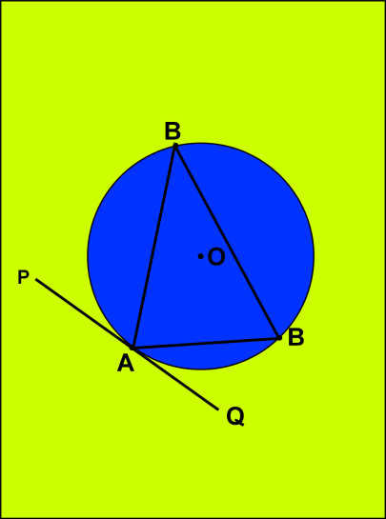
- Take a point D on the minor arc. Form a crease joining AD. Draw AC.
- Form a crease joining BD. Draw BD.
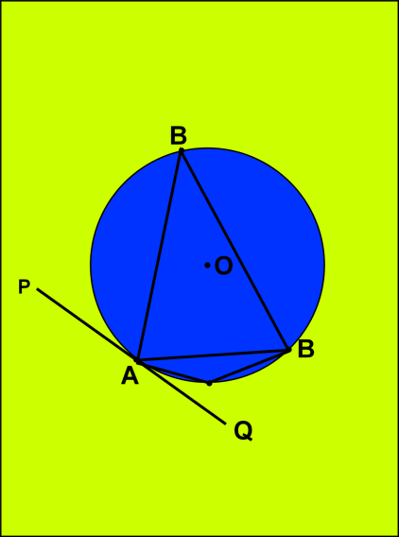
- Make a replica of $∠ACB$ using a tracing paper. Place it on $∠BAQ$.
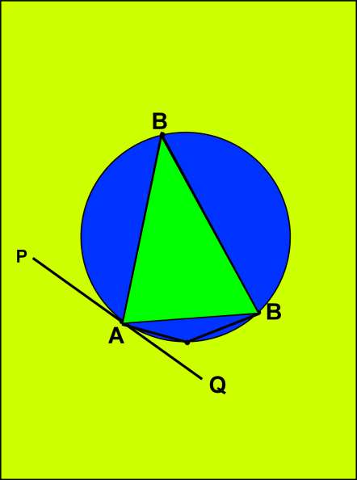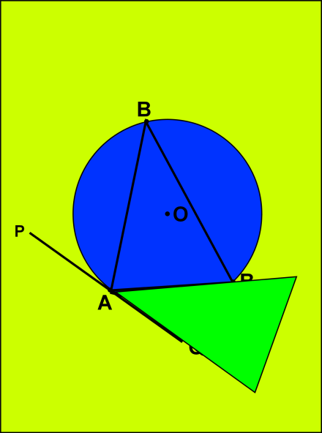
- Make a replica of $∠BDA$ using a tracing paper. Place it on $∠BAP$.
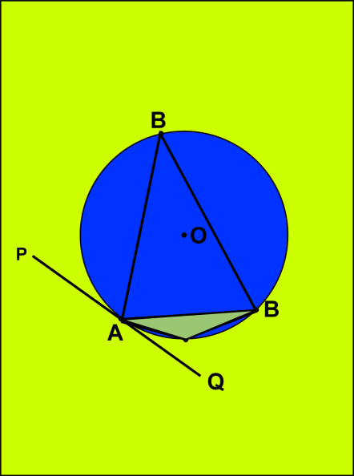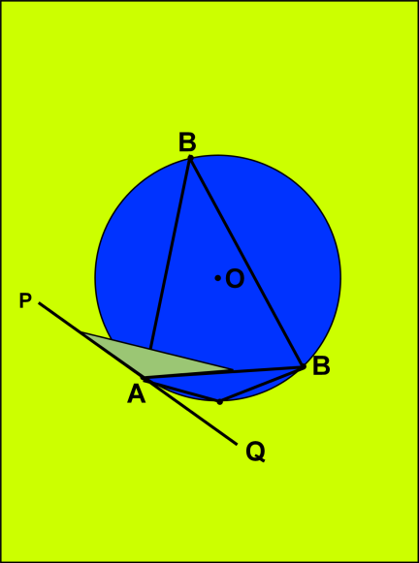

RESULT:
It is noted that $∠BAP and ∠BAQ are the angles formed between the chord AB and the tangent PQ.$. $∠BAQ$ is completely covered with $∠ACB$ and $∠BAP$ is completely covered with $∠ADB$. Thus the theorem is verified.
LAST DATE OF SUBMISSION OF PROJECT: 23rd April, 2018

- TOPIC: ANGLES IN THE SAME SEGMENT OF A CIRCLE ARE EQUAL
OBJECTIVE: To verify that the angle in the same segment of a circle are equal using the method of cutting, pasting and folding.
MATERIALS REQUIRED:
- Geometry box
- Practical workbook
- Coloured chart papers – yellow, blue and red
- Scissors
- Scale
- Sketch pen
- Adhesives or glue sticks
- Tracing papers – 2
PROCEDURE:
- Draw a circle of 5 cm radius on a blue coloured chart paper. Use black sketch pen for drawing.
- Cut out the circle.
- Take a yellow chart paper. Cut it in the size of an A4 sheet and paste the circle on it.
- Fold the circle in any way such that a chord is made. Draw the line segment AB.
- Take two points P and Q on the circle in the same segment.
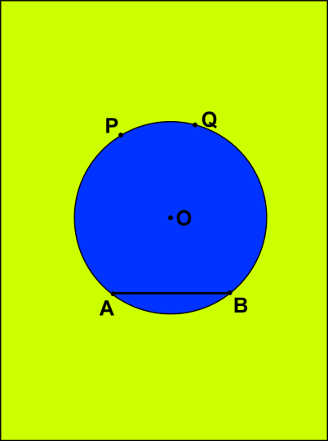
- Form a crease joining AP. Draw AP.
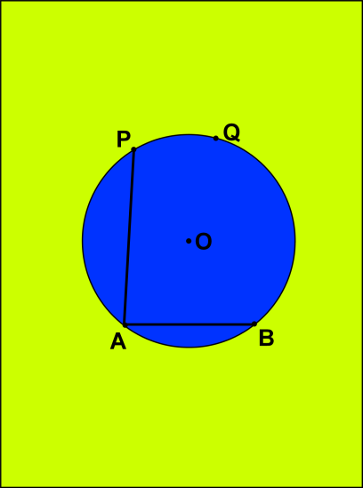
- Form a crease joining BP. Draw BP.
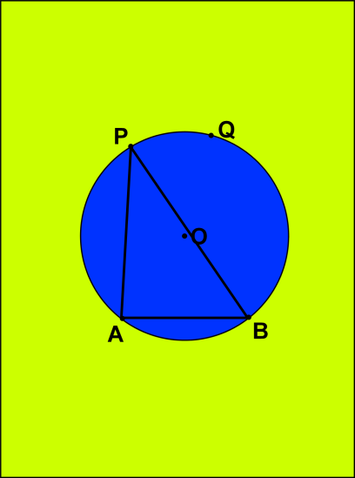
- $∠APB$ is formed in the major segment.
- Form a crease joining AQ Draw AQ.
- Form a crease joining BQ. Draw BQ.
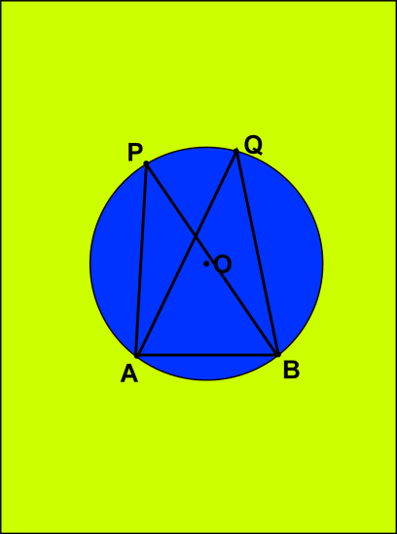
- $∠AQB$ is formed in the major segment.
- Place tracing paper on the circle and draw a replica of the $∠APB$ and $∠AQB$. Prepare two such replicas of $∠APB$ with green or red chart papers.
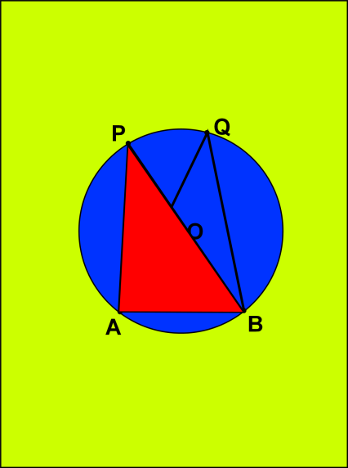
- Place the cutout of $∠APB$ on $∠AQB$. Stick the other replica along the edge BQ.

RESULT:
It is noted that $∠APB$ = $∠AQB$ and these angles are in the same segment. $∠APB$ is completely covered with $∠AQB$ and thus the theorem is verified.
LAST DATE OF SUBMISSION OF PROJECT: 7th May, 2018

