Proposed Projects for History and Civics [HCGI] SECOND TERM 2017-2018
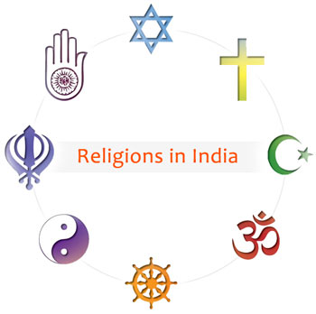
Last Date of Submission : 15th January 2017
Class 5 : Topic- Religion in India : Significance
on Chart Paper.

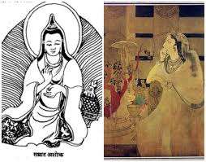
Class 6 : Topic- Ashoka ,the dhamma king
How from a fierce warrior he became a
Dhamma king? What is Dhamma?

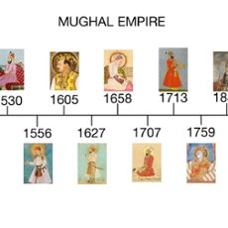
Class 7 : Topic Chronology of the Mughals .
Collage making.

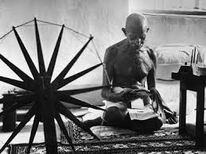
Class 8: Topic- Gandhi and his 3 Movements; Comparative study.

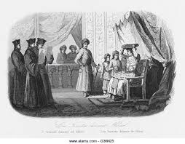
Class 9: Topic-The Sultans and Mughal..Model Making/paintings
in group.

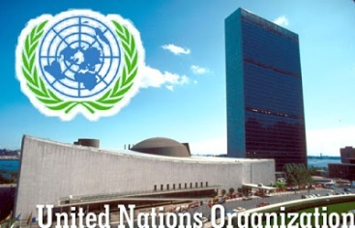
Class 10: Topic- UNO..a survey . .

NOTE: All Projects are Class Projects of the above mentioned Classes and will have 5 marks Aural.
Proposed Projects for Geography [HCGII] 2nd TERM 2017-2018
Last Date of Submission : 15th January 2017
Class 5 : Topic- Green Earth..based on chart

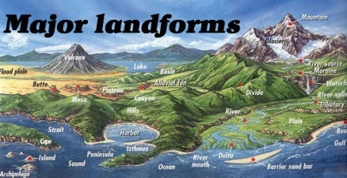
Class 6 : Topic- World and Landforms.
A model with specifics .

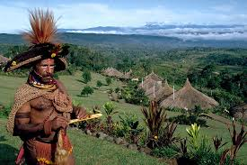
Class 7 : Topic- Case Study on Guinea Island of South America
- Location, 2. Formation 3.Importance
File Project.

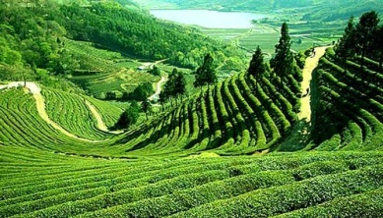
Class 8 : Topic- Case study on Tea and Rubber plantations in India.
Class Project in File.
.
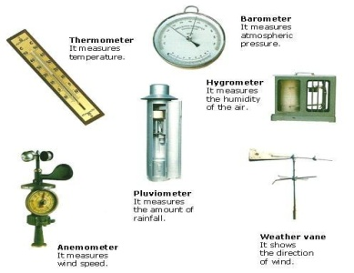
Class 9 : Topic- Meterological instruments and their uses[pg 65 of the
Syllabus Book of ICSE]
Practical work 1.a,b & e. File Project.

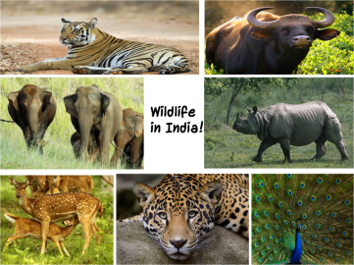
Class 10 : Topic- Wildlife in India .
File Project.

NOTE: All Projects are Class Projects of the above mentioned Classes and will have 5 marks Aural.

Proposed Projects for Environmental Education SECOND TERM 2017-2018
Last Date of Submission : 15th of JANUARY 2017
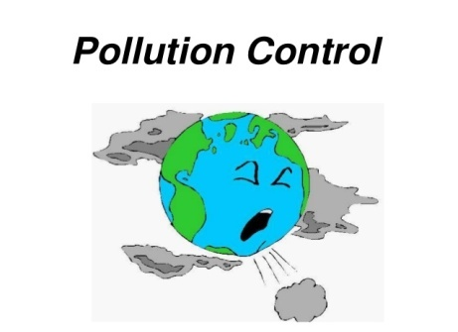

Class 5 : Topic- Pollution Control.
On Chart Paper, Class Project.

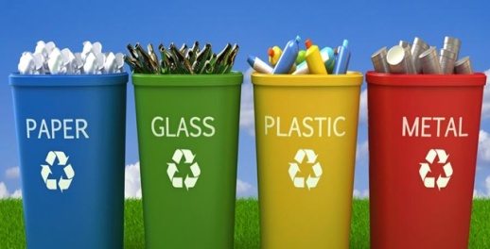
Class 6 : Topic-Management of Waste- Different methods
To be explained.
Class Project On File Paper.

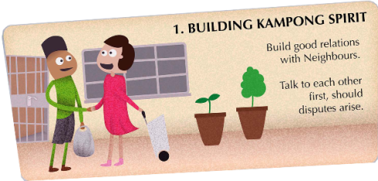
Class 7 : Topic- Good Neighbourly Behaviour : At least 5 behaviours those are positive.
Chart based Project.

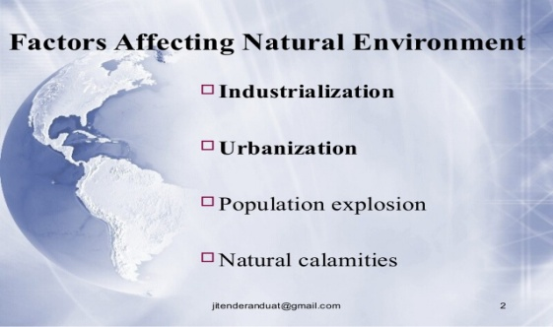
Class 8 : Topic-Factors affecting environment..
File Project.

NOTE: All Projects are Class Projects of the above mentioned Classes and will have 5 marks Aural.

