Proposed Projects for Environmental Education for 1st Term 2016-2017
Last Date of Submission : 15th of July 2016

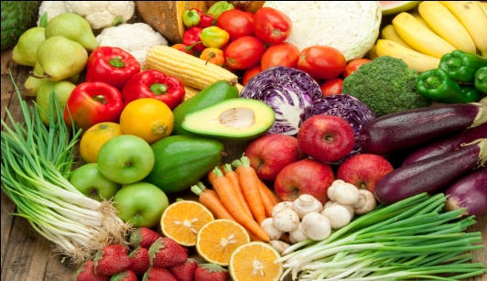
Class 5 : Topic- Our Food and Us. In file ,Class Project.

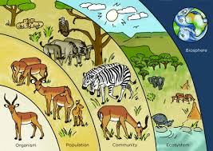
Class 6 : Topic- Interdependence in Environment.
In Chart Paper, Class Project.

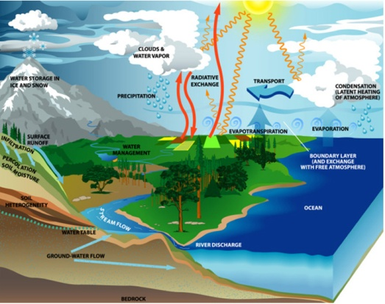
Class 7 : Topic- Water- A precious resource. File Project.

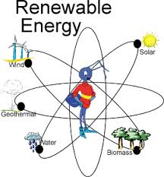
Class 8 : Topic- Renewable Sources of Energy. File Project.

