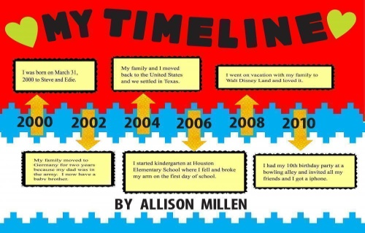
Proposed Projects for History and Civics [HCGI] FIRST TEM 2017-2018
Last Date of Submission : 15th July 2017
Class 5 : Topic- Time Line : significance of Time Line ,
on Chart Paper

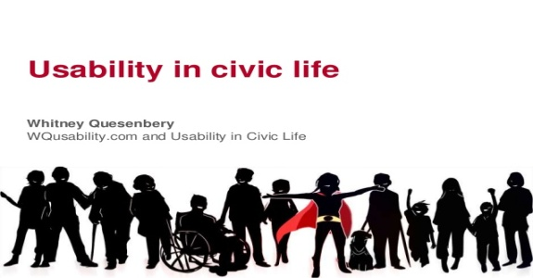
Class 6 : Topic- Importance of Civic Life
, Emphasise on at least 3 aspects of Civic life
An pictorial expression: through collage.

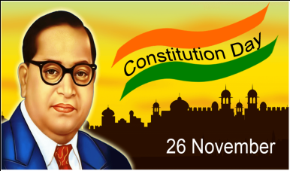
Class 7 : Topic- Democratic,Sovereign,Secular,Socialist,Republic.
Pictographic expression on the specifics and
significance on the Chart.
Class 8: Topic- India and Globalisation; Explain through Model.

Class 9: Topic-An analytical review of the Film ‘Mohenjo Daro’, and its relevance
of History.

Class 10: Topic- An Autobiography of an Assertive Nationalist ,during Partion of Bengal.
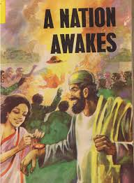
NOTE: All Projects are Class Projects of the above mentioned Classes and will have 5 marks Aural.
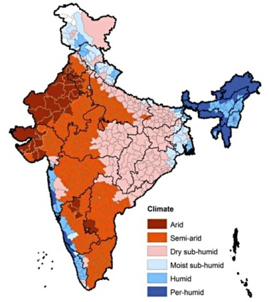
Proposed Projects for Geography [HCGII] TERM 2017-2018
Last Date of Submission : 15th July 2017
Class 5 : Topic- Soil as an important resource: students will write and draw
A soil profile,usefulness of different soil types in India and method
Of soil conservation. On a map students should mark the region of
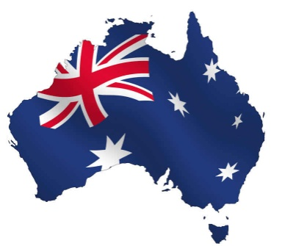
Alluvial soil,black soil,red soil, and laterite soil on Chart Paper.

Class 6 : Topic- Knowing Austrlia.
A model with specifics.

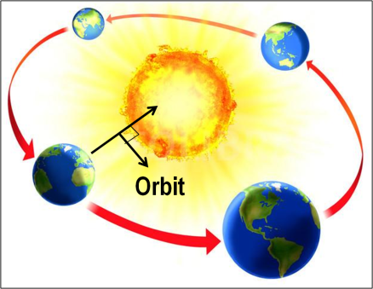
Class 7 : Topic- Motions of the Earth with special
Rotation-Day and Night and Heat Zones .
Revolution-Seasons, Aphelion and Perihelion
File Project.

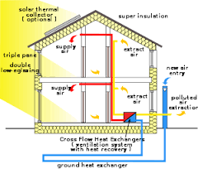
Class 8 : Topic- Kinds of Houses depending on the Climatic Regions.
Make a collage of different kinds of Houses built across
The World depending on the Climatic regions of those regions.

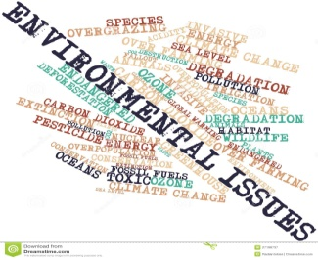
.Class 9 : Topic- Kinds Collect information about Global environmental issues
And problems . Ex. Pollution,Population Explotion, extinct of wildlife &
Land degradation. File Project.

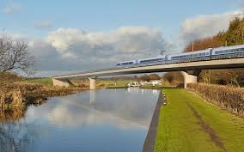
Class 10 : Topic- Transport in India Road,Rail,Water and Air routes.
File Project.

NOTE: All Projects are Class Projects of the above mentioned Classes and will have 5 marks Aural.

Proposed Projects for Environmental Education FIRST TERM 2017-2018
Last Date of Submission : 15th of July 2017
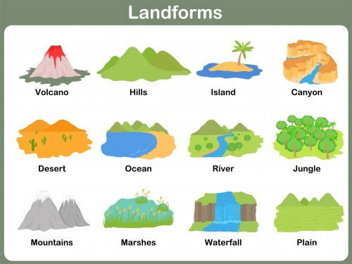

Class 5 : Topic- Different types of Landforms and Habitat.
On Chart Paper, Class Project.

Class 6 : Topic-Draw a poster on different kinds of agricultural growth.
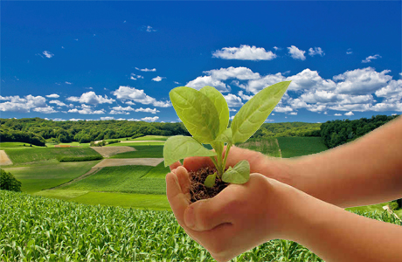
On Chart Paper.

Class 7 : Topic- Life in Sea-Different Zones and Adaptations shown by marine
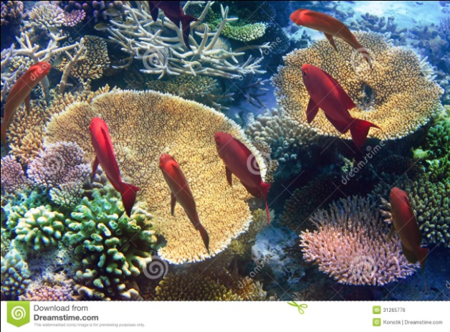
Plants and Organisms in the Sea.
Chart based Project.

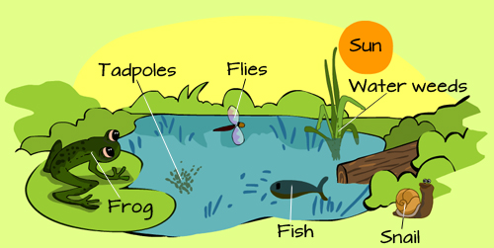
Class 8 : Topic-Eco SystemComponents and Interactions.Types of Eco System.
File Project.

NOTE: All Projects are Class Projects of the above mentioned Classes and will have 5 marks Aural.

