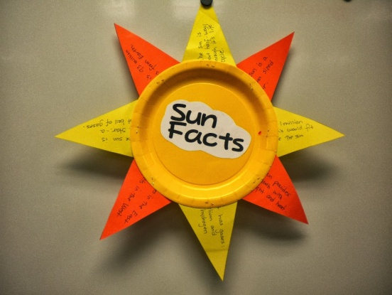**Topics Of Geography Projects 2nd Term, 2014-15**

**CLASS 5 - INDIA AND ITS NEIGHBOURS**

**CLASS 6 –**

**AFRICA –LAND AND PEOPLE**

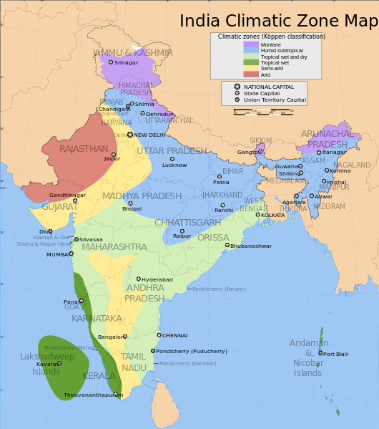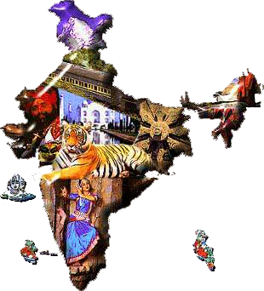

**CLASS 9 –**

**USES OF IMPORTANT TYPES OF MAPS**

**READING AND USING STATEMENT OF SCALE,GRAPHICAL SCALE AND REPRESENTATIVE FRACTION METHOD(NO DRAWING WORK ONLY EXPLAINING THEIR MEANING)**

**DRAWING AND RECOGNISING FORMS OF IMPORTANT CONTOURS.**

**CLASS 10 –**

**WILDLIFE CONSERVATION EFFORTS IN INDIA.**

**CLASS 7 – CASE STUDY ANTARCTICA-A FROZEN CONTINENT.**

**CLASS 8 –**

**NATURAL VEGETATION OF INDIA**

**AFRICA –LAND AND PEOPLE**