GEOGRAPHY PROJECTS OF Final Term Evaluation 2015-2016
TOPICS :

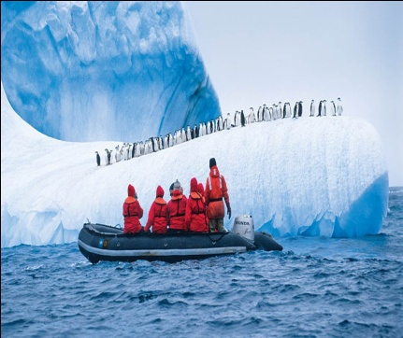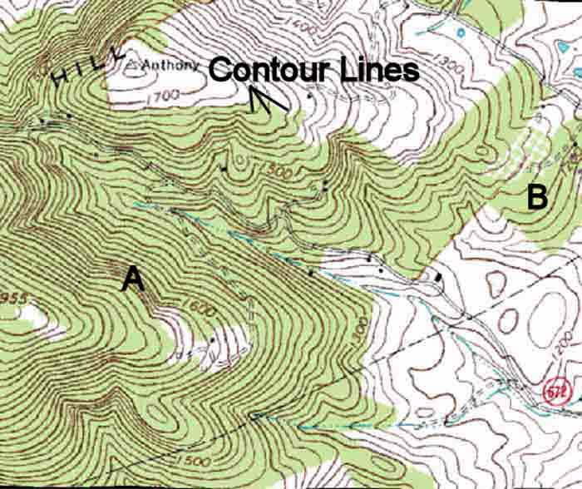

CLASS 5: Know your neighbouring Countries. Write on inter leaf paper 5 points each of neighbouring countries.

CLASS 6 : Case Study o Nile River Valley and the pyramids in Egypt. Project will be done on File Paper.

CLASS 7: Case study on Antarctica. Project will be done on a file.

CLASS 8: The diversity of Natural Vegetation and Wildlife in India. Project will be done on file.
CLASS 9: Practical work on: Contours. Project will be done in the Class.

CLASS 10 : Needs for Industrialisation in India, the latest trends and its impact on economy of India. Project will be done on File.
