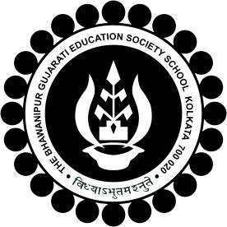
The BGES School(ICSE)
12B Heysham Road
Kolkata 200020

Administrative Instruction-Annual Function 2018-19
On Saturday 5th May 2018 there will be no clubs. All students must be present in the groups allotted to them for the practise of Annual Function.
Meeting and showcase along with Mr. Sumit Ray has been postponed to Monday at 1000 hrs.
Review for the same in First Floor Hall at 1200hrs on Saturday 5th May.
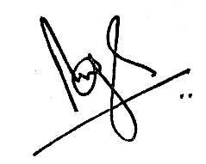
Brij Bhushan Singh
Headmaster
03 May 2018

