Proposed Projects for History and Civics [HCGI] FIRST TERM 2018-2019
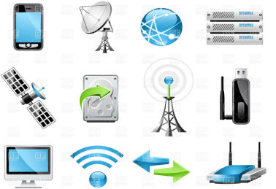
Last Date of Submission : 15th July 2018
Class 5 : Topic- Upgradation of Means of Communication
: A collage on half of the Chart Paper.

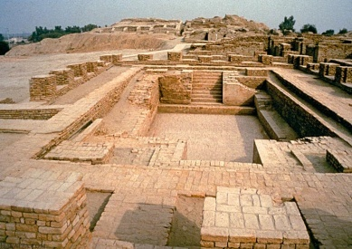
Class 6 : Topic- Harappan Civilization: create a sand art
On 1/4th Chart Paper on Great Bath

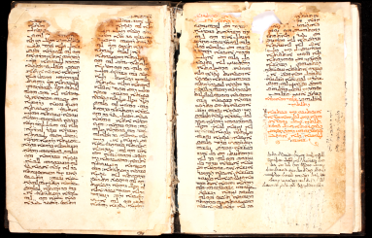
Class 7 : Administrative Measures Taken by Alauddin Khilji,
Muhammad Bin Tughlaq, Sher Shah and Akbar .
Create a diary as the Source of History.On a booklet
Will be provided by the Teacher.
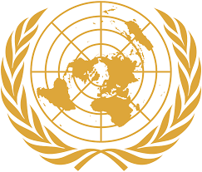

Class 8: Topic- UNO: Symbol of UNO. Model Making. Nono

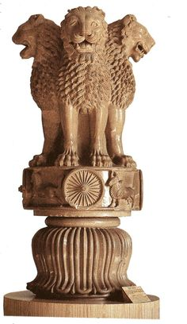
Class 9: Topic-Ashoka The Great. His traits, Dhamma, present every day use
Of Ashoka.Model Making. Students are not allowed to use any
Sort of plastic or thermocol.

Class 10: Topic- Comaparative study between Early and Later Nationalists
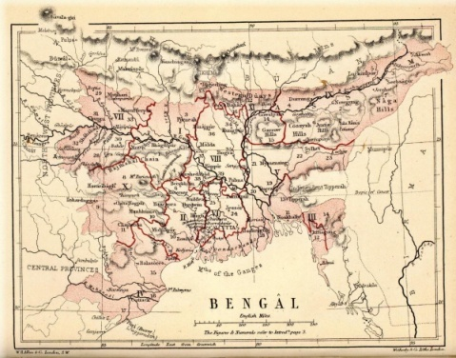
In the Project File. .

NOTE: All Projects are Class Projects of the above mentioned Classes and will have 5 marks Aural.

