MATHEMATICS PROJECT
CLASS: 9B

TOPIC: TO PROVE BY PAPERFOLDING METHOD THE POSTULATE OF PYTHAGORAS THEOREM, $P^{2}+B^{2}=H^{2}$, WHERE P = Perpendicular or the side opposite to the angle in consideration, B = base or the adjacent side and H = hypotenuse.

OBJECTIVE: To verify Pythagoras Theorem, using methods of paper cutting, pasting and folding.

MATERIALS REQUIRED:
- Geometry box
- Practical workbook
- Coloured chart papers – yellow, light green, pink and orange
- Scissors
- Plastic Ruler (15 cm)
- Sketch pen
- Adhesives or glue sticks
- Tracing papers – 2
PROCEDURE:

- Draw a. right angled triangle on a tracing paper with the measurements of P = 3 cm, B = 4 cm, H + 5 cm.
- Place the tracing paper on top of the yellow chart paper.
- Trace the triangle and cut it out properly.
- Check the measurement using Rulers if it is cut out properly.
- Mark the triangle as shown in the figure.
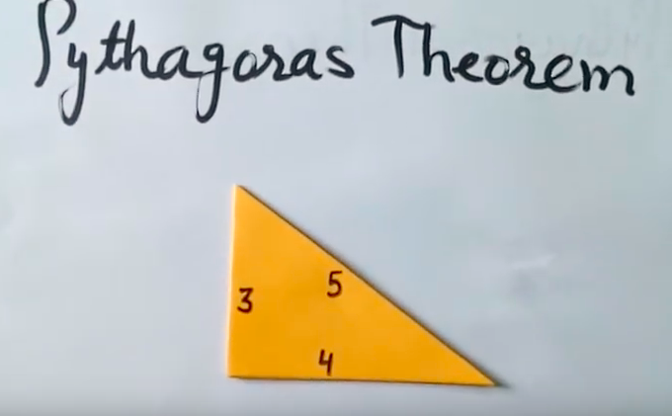
- Construct a square using compass and ruler of edges 3 cm each on the tracing paper.
- Pste the yellow triangle at the centre of the white page of your mathematics project file.
- Cut out two pink squares by placing the tracing paper on the pink chart paper and paste one of it as shown on the white page.
- Like wise complete the remaining squares as shown.

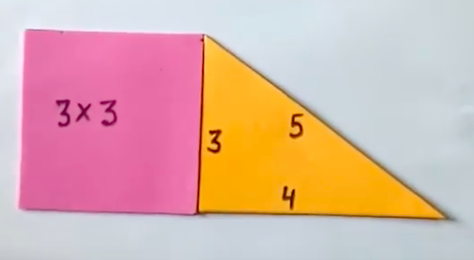

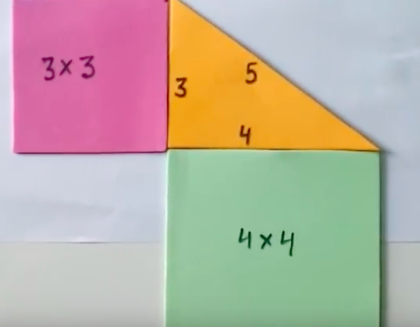

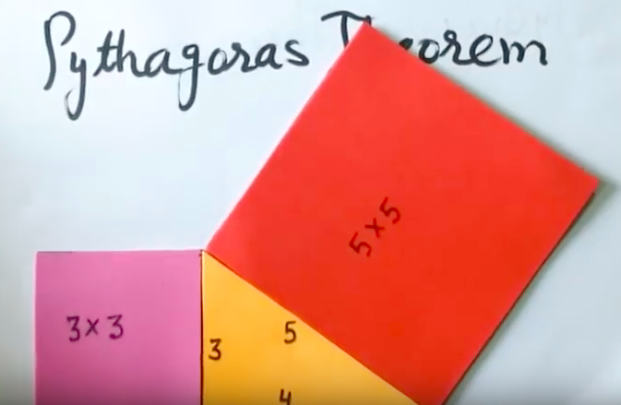

- Now take the second pink square.
- Mark three points each of 1 cm width on its two adjacent edges as shown.
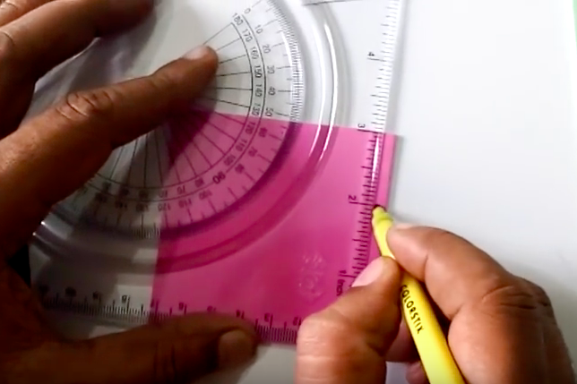

- Draw lines with black sketch pen as shown on each of the three different squares of red, light blue and red.

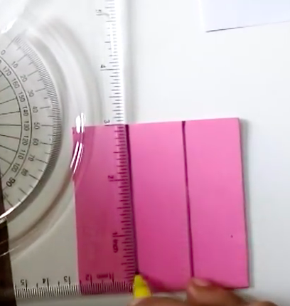

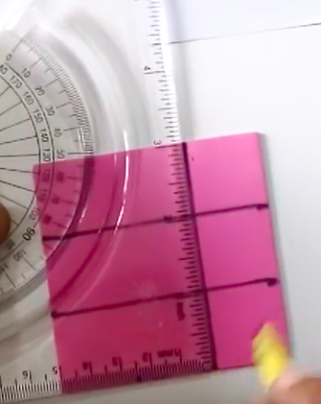

- Paste the squares as shown.

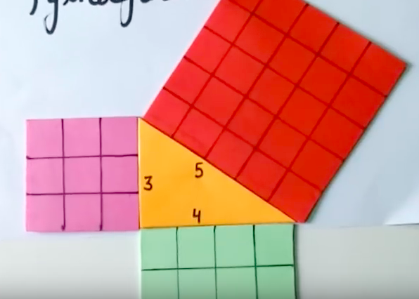

- Start filling up each small box starting from 1 as shown.
- You will find the pink square has small boxes written from 1 to 9, green from 1 to 16, red from 1 to 25.
- Paste them as shown.
- As square of 3 is 9, 4 is 16 and 5 is 25, we find $3^{2}+4^{2}=5^{2}.$
- Hence the Theorem is proved.

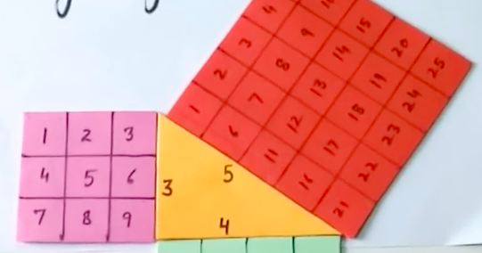

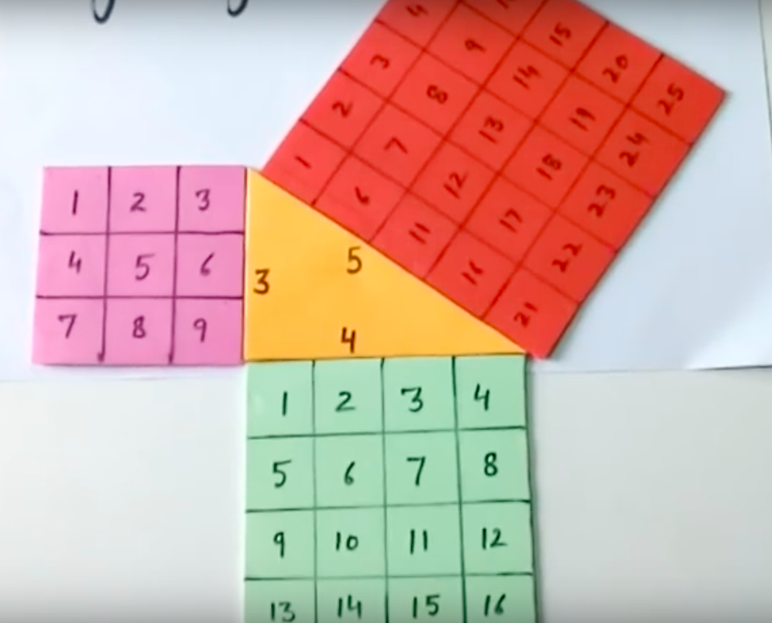

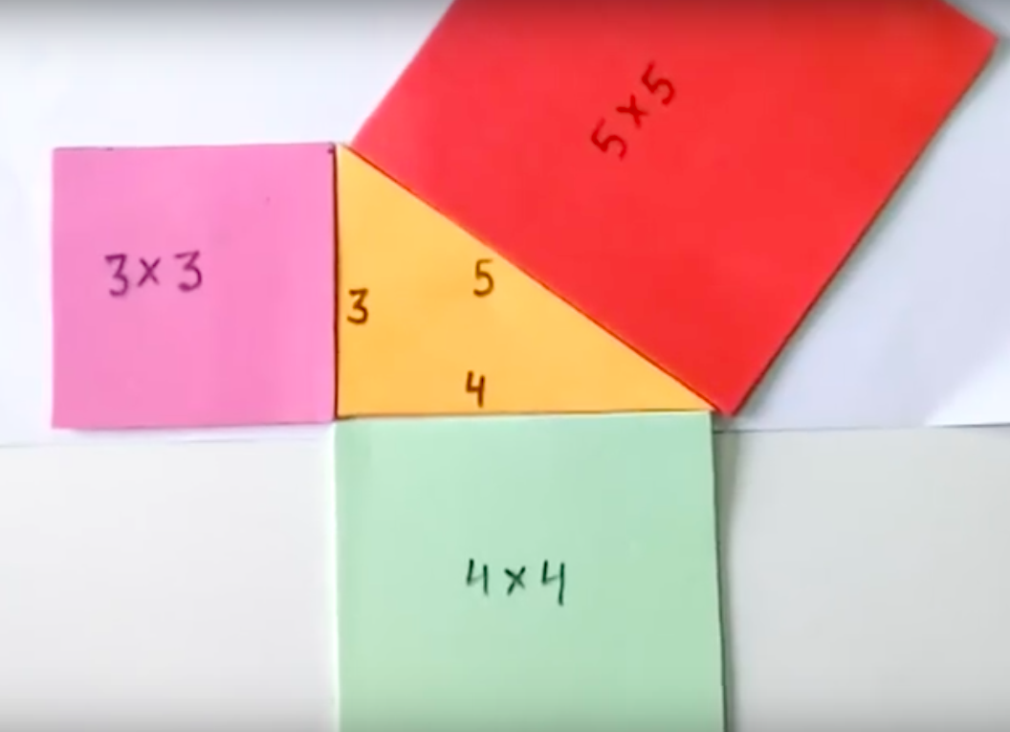

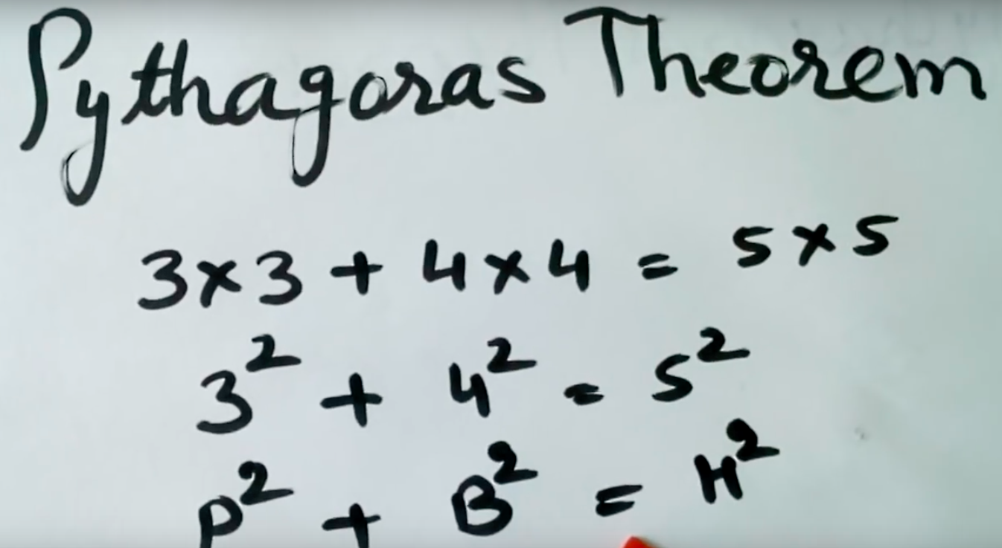

RESULT:
It is noted that Pythagoras Theorem is hence proved.
LAST DATE OF SUBMISSION OF PROJECT: 23rd April, 2018.

