Proposed Projects for History and Civics [HCGI] FINAL TERM 2018-2019
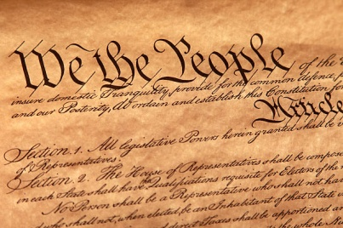
Last Date of Submission : 15th January 2018
Class 5 : Topic- The Constitution of India
: 5 Features on the Chart Paper in Kite shaped.

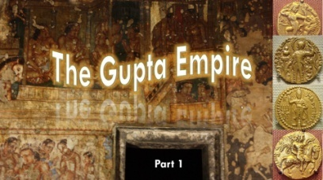
Class 6 : Topic- The Gupta Age: Why known as Golden Age
In a booklet form made out of Chart Paper.

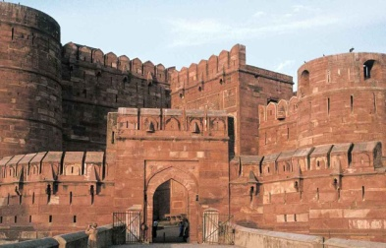
Class 7 : Topic:Taj Mahal, Diwan i Am, Agra Fort, Red Fort
Make a model by using paper and colour. No thermocol
Or plastic should be used. Height and base should not be
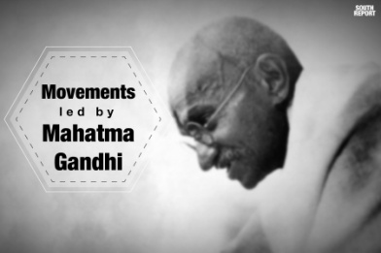
More than 20cm by 20cm. Individual Project on any one of the source.

Class 8: Topic- Movements Lead by Gandhi.
Picture collage to elaborate the chronological trail of history.

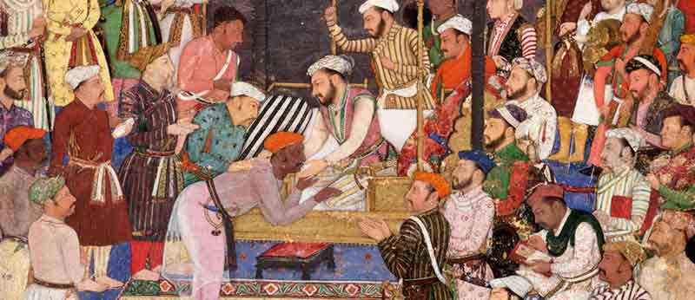
Class 9: Topic-The Sources of the Mughal Empire
A manuscript on any one of the source.

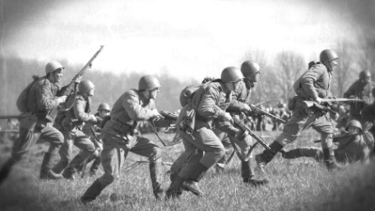
Class 10: Topic- Seeds of World War II was embedded in the Consequences of WWI. Aftermath
Critical Analysis In the Project File. .

NOTE: All Projects are Class Projects of the above mentioned Classes and will have 5 marks Aural.

